

Lab 9
Name: Ayesha Amjad
SAP: 82690
Course: DSA
Semester: 3rd

Task 1: Conversion
In infix to postfix conversion, operands are written directly in the output, while operators are placed on a stack. Multiplication (*) and division (/) have higher precedence than addition (+) and subtraction (-). Brackets are solved first.
1. A+B*C
Postfix: ABC*+
Character | Stack | Postfix output
A | Empty | A
+ | + | A
B | + | AB
* | +, * | AB
C | +, * | ABC
End | Empty | ABC*+

Explanation: The + operator is pushed first. The * operator is pushed because it has higher precedence than +. At the end, * is popped first and then +.
2. (A-B)*C
Postfix: AB-C*
Character | Stack | Postfix output
( | ( | Empty
A | ( | A
- | (, - | A
B | (, - | AB
) | Empty | AB-
* | * | AB-
C | * | AB-C
End | Empty | AB-C*

Explanation: The opening bracket is pushed onto the stack. The - operator is pushed after it. When the closing bracket is found, - is popped to the output and the opening bracket is removed. Then * is pushed and popped at the end.
3. A*B+C/D
Postfix: AB*CD/+
Character | Stack | Postfix output
A | Empty | A
* | * | A
B | * | AB
+ | + | AB*
C | + | AB*C
/ | +, / | AB*C
D | +, / | AB*CD
End | Empty | AB*CD/+

Explanation: When + is scanned, * is popped because it has higher precedence. Then + is pushed. The / operator is pushed because it has higher precedence than +. At the end, / is popped first and then +.
Task 2: Dry Run
Expression: (A+B)*C
Postfix output: AB+C*
The following table shows the stack and postfix output after each character is scanned.
Scanned character | Current stack | Postfix output so far
( | ( | Empty
A | ( | A
+ | (, + | A
B | (, + | AB
) | Empty | AB+
* | * | AB+
C | * | AB+C
End (pop remaining operator) | Empty | AB+C*

Explanation:
1. The opening bracket ( is pushed onto the stack.
2. A is an operand, so it is added directly to the postfix output.
3. The + operator is pushed onto the stack.
4. B is an operand, so it is added directly to the postfix output.
5. When ) is scanned, + is popped and added to the output. The opening bracket is then removed.
6. The * operator is pushed onto the stack.
7. C is an operand, so it is added directly to the postfix output.
8. At the end, * is popped and added to the postfix output.
Answer: AB+C*
Task 3:
Code:
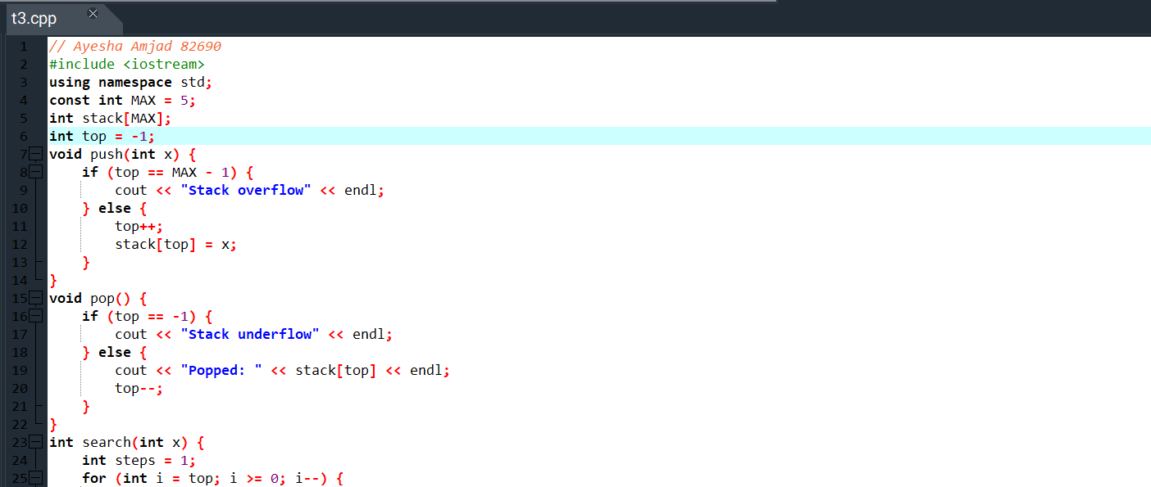
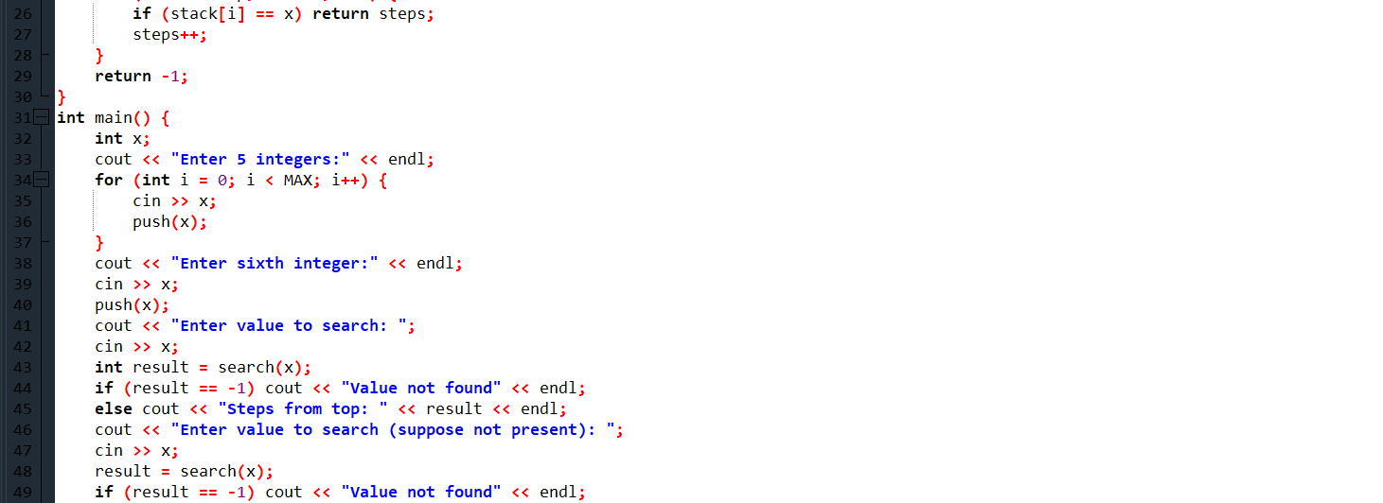
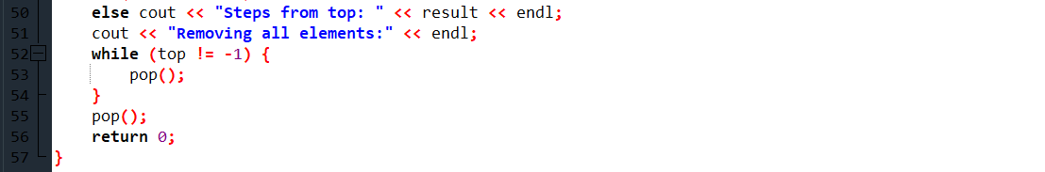
Output:


